**Action 1: -**

Create a database named employee, then import data_science_team.csv proj_table.csv and emp_record_table.csv into the employee database from the given resources.

**Answer –**

**create database employee;**

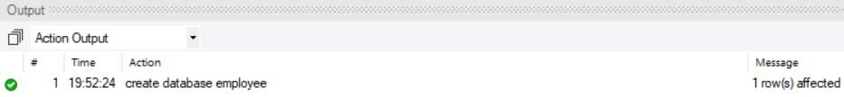

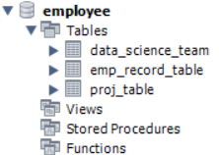

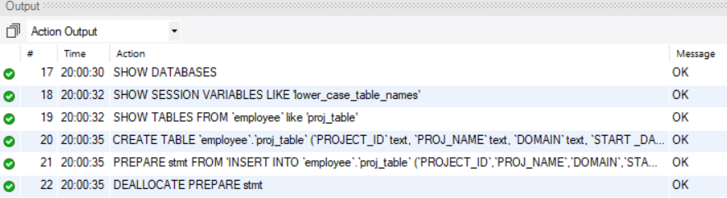

**Action 2: -**

Create an ER diagram for the given employee database.

**Answer –**

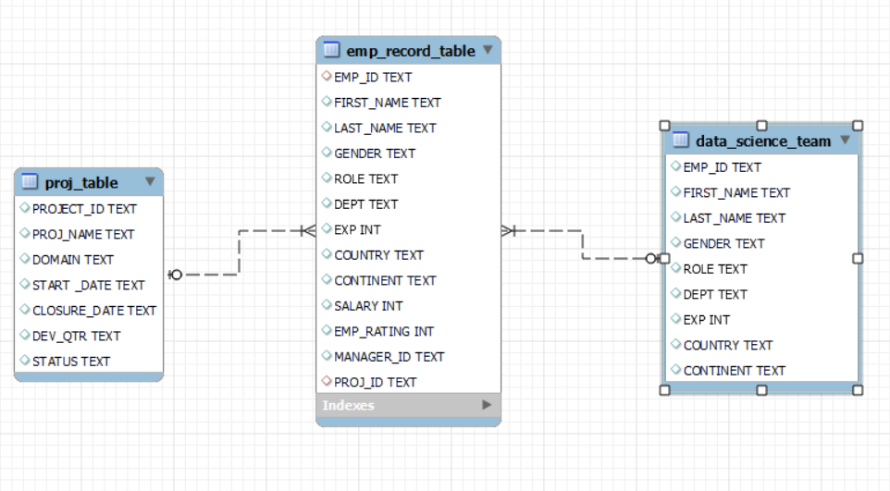

**Action 3: -**

Write a query to fetch EMP_ID, FIRST_NAME, LAST_NAME, GENDER, and DEPARTMENT from the employee record table, and make a list of employees and details of their department.

**Answer -**

select EMP_ID, FIRST_NAME, LAST_NAME, GENDER, DEPT FROM

emp_record_table order by dept;

**Output**

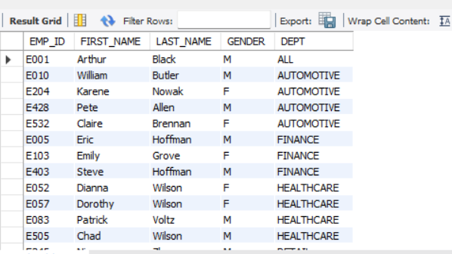

**Action 4: -**

Write a query to fetch EMP_ID, FIRST_NAME, LAST_NAME, GENDER, DEPARTMENT, and EMP_RATING if the EMP_RATING is:

* less than two
* greater than four
* between two and four

**Answer –**

select EMP_ID, FIRST_NAME, LAST_NAME, GENDER, DEPT,EMP_RATING,

case

when EMP_RATING < 2 then 'Less then 2'

when EMP_RATING < 4 then 'between two and four'

else 'greater than four '

end as Rating

from emp_record_table order by dept;

**Output**

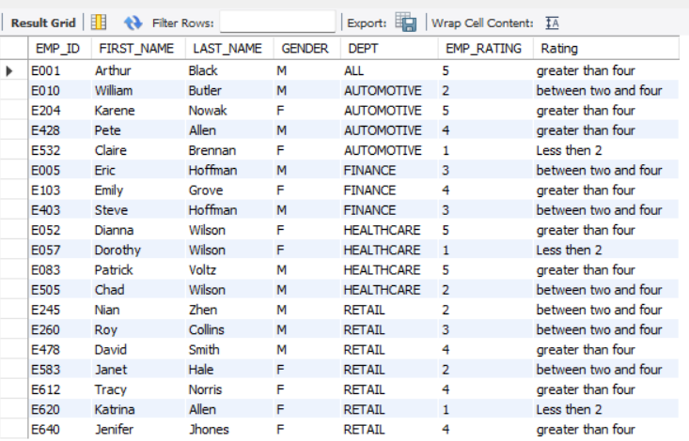

**Action 5: -**

Write a query to concatenate the FIRST_NAME and the LAST_NAME of employees in the Finance department from the employee table and then give the resultant column alias as NAME.

**Answer –**

select concat(first_name," ",last_name) as Name

from emp_record_table

where DEPT = 'FINANCE';

**Output**

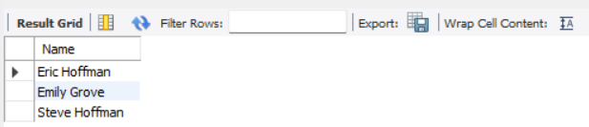

**Action 6: -**

Write a query to list only those employees who have someone reporting to them. Also, show the number of reporters (including the President).

**Answer –**

select m.FIRST_NAME as manager_name, count(*) No_Emps_reporting

from emp_record_table as e

join emp_record_table as m

on m.emp_id=e.MANAGER_ID

group by manager_name

having count(*) > 0;

**OUTPUT**

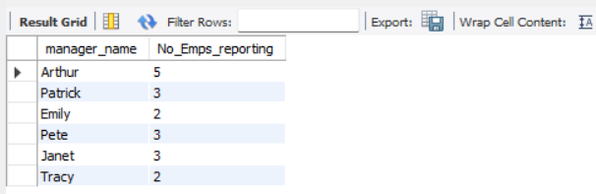

**Action 7: -**

Write a query to list down all the employees from the healthcare and finance departments using union. Take data from the employee record table.

**Answer –**

select * from emp_record_table where DEPT = 'Healthcare'

UNION

select * from emp_record_table where DEPT = 'Finance';

**OUTPUT**

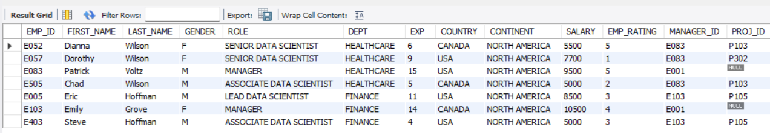

**Action 8: -**

Write a query to list down employee details such as EMP_ID, FIRST_NAME, LAST_NAME, ROLE, DEPARTMENT, and EMP_RATING grouped by dept. Also include the respective employee rating along with the max emp rating for the department.

**Answer –**

select EMP_ID,FIRST_NAME,LAST_NAME,Role,DEPT, EMP_RATING,

max(emp_rating) over(partition by DEPT) max_rating

from emp_record_table;

**OUTPUT**

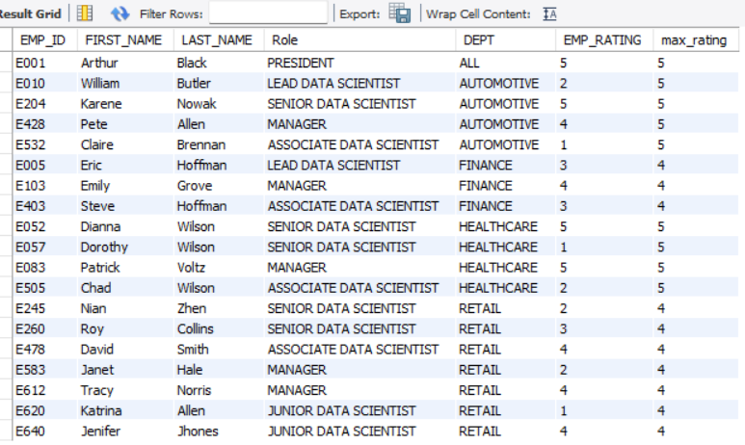

**Action 9: -**

Write a query to calculate the minimum and the maximum salary of the employees in each role. Take data from the employee record table.

**Answer -**

select role,min(Salary) Min_Salary ,Max(Salary) MAX_Salary from emp_record_table

group by ROLE;

**OUTPUT**

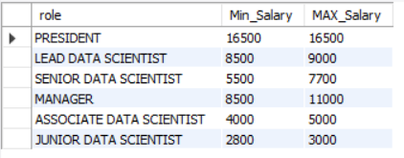

**Action 10: -**

Write a query to assign ranks to each employee based on their experience. Take data from the employee record table.

**Answer –**

select emp_ID,First_Name,Exp,Rank() over(order by Exp desc) Rank_Exp

from emp_record_table;

**OUTPUT**

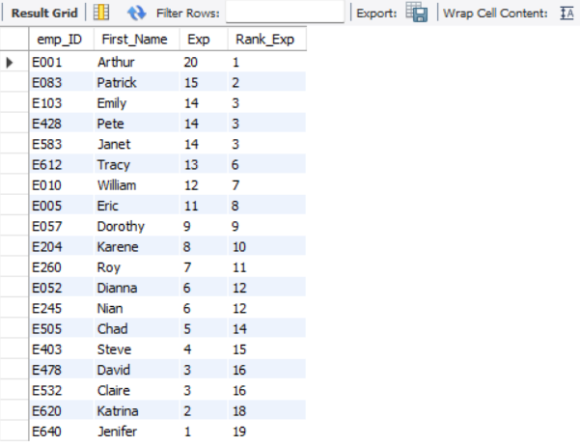

**Action 11: -**

Write a query to create a view that displays employees in various countries whose salary is more than six thousand. Take data from the employee record table.

**Answer –**

create VIEW VempSalAbove6k

AS

select EMP_ID,FIRST_NAME,LAST_NAME,SALARY,COUNTRY from emp_record_table

where SALARY > 6000;

select * from VempSalAbove6k;

**OUTPUT**

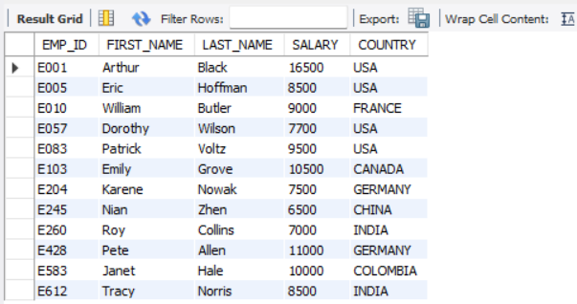

**Action 12: -**

Write a nested query to find employees with experience of more than ten years. Take data from the employee record table.

**Answer –**

select * from emp_record_table where EMP_ID in(

select Emp_ID from emp_record_table where Exp > 10);

**OUTPUT**

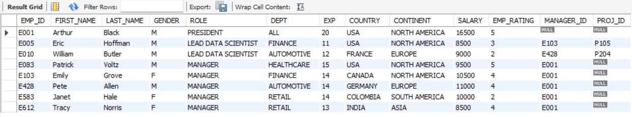

**Action 13: -**

Write a query to create a stored procedure to retrieve the details of the employees whose experience is more than three years. Take data from the employee record table.

**Answer –**

USE `employee`;

DROP procedure IF EXISTS `employee`.`emp_3plusExp`;

;

DELIMITER $$

USE `employee`$$

CREATE PROCEDURE `emp_3plusExp`()

BEGIN

select * from emp_record_table where Exp > 3;

END$$

DELIMITER ;

;

call emp_3plusExp;

**OUTPUT**

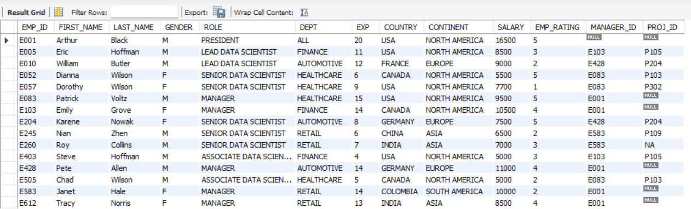

**Action 14: -**

Write a query using stored functions in the project table to check whether the job profile assigned to each employee in the data science team matches the organization’s set standard.

The standard being:

For an employee with experience less than or equal to 2 years assign 'JUNIOR DATA SCIENTIST',

For an employee with the experience of 2 to 5 years assign 'ASSOCIATE DATA SCIENTIST',

For an employee with the experience of 5 to 10 years assign 'SENIOR DATA SCIENTIST',

For an employee with the experience of 10 to 12 years assign 'LEAD DATA SCIENTIST',

For an employee with the experience of 12 to 16 years assign 'MANAGER'.

**Answer-**

CREATE DEFINER=`root`@`localhost` FUNCTION `Check_Job_Profile`(EXP INT, ROLE VARCHAR(50)) RETURNS varchar(50) CHARSET utf8mb4

DETERMINISTIC

BEGIN

declare Expected_Role varchar(50);

IF EXP <= 2 THEN

SET expected_role = 'JUNIOR DATA SCIENTIST';

ELSEIF EXP BETWEEN 3 AND 5 THEN

SET expected_role = 'ASSOCIATE DATA SCIENTIST';

ELSEIF EXP BETWEEN 6 AND 10 THEN

SET expected_role = 'SENIOR DATA SCIENTIST';

ELSEIF EXP BETWEEN 11 AND 12 THEN

SET expected_role = 'LEAD DATA SCIENTIST';

ELSEIF EXP BETWEEN 13 AND 16 THEN

SET expected_role = 'MANAGER';

ELSE

SET expected_role = 'UNKNOWN ROLE'; ## In case an experience level doesn't match the standard

END IF;

IF expected_role = ROLE THEN

RETURN 'MATCH';

ELSE

RETURN CONCAT('MISMATCH (Expected: ', expected_role, ')');

END IF;

RETURN expected_role;

END

**QUERY**

SELECT DS.EMP_ID, DS.FIRST_NAME, DS.LAST_NAME, DS.EXP, DS.ROLE AS CURRENT_ROLE,

Check_Job_Profile(DS.EXP, DS.ROLE) AS ROLE_VALIDATION

FROM emp_record_table DS

order by EXP desc, CURRENT_ROLE asc;

**OUTPUT**

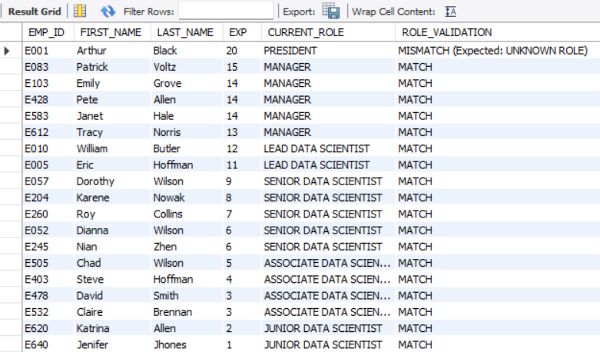

**Action 15: -**

Create an index to improve the cost and performance of the query to find the employee whose FIRST_NAME is ‘Eric’ in the employee table after checking the execution plan.

**Answer –**

**select * from emp_record_table where FIRST_NAME = 'Eric';**

**BEFORE**

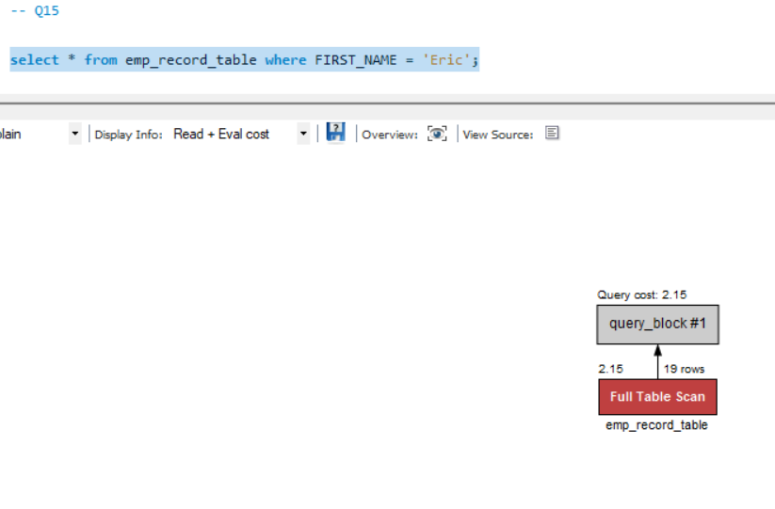

**AFTER**

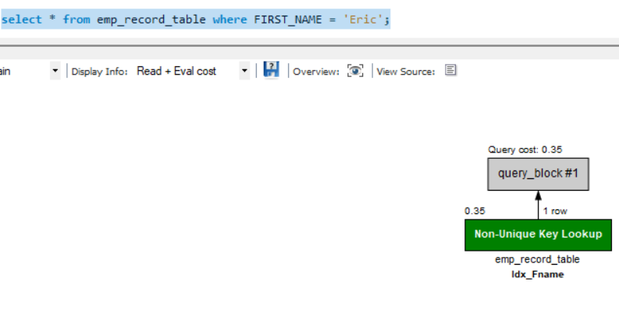

**OUTPUT**



**Action 16: -**

Write a query to calculate the bonus for all the employees, based on their ratings and salaries (Use the formula: 5% of salary * employee rating).

**Answer –**

select *,

SALARY *.05 * EMP_RATING as Bonus from emp_record_table;

**OUTPUT**

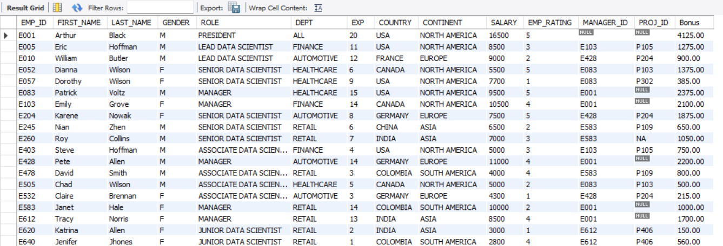

**Action 17: -**

Write a query to calculate the average salary distribution based on the continent and country. Take data from the employee record table.

**Answer –**

select CONTINENT, COUNTRY, avg(Salary) as AVg_Salary

from emp_record_table

group by CONTINENT, COUNTRY with rollup;

**OUTPUT**

